TF-IDF or Word Embedding Features

Definition
# Source: AI Source: Provided by: [Data Path: Persons Table -> ID Column: 1, Name_En Column: Motasem Essam] -> From: [ChatGPT] on [12/10/2025]
TF-IDF or Word Embedding Features are numerical representations of text used in machine learning and NLP. They transform raw text into vectors that can be processed by models:
- TF-IDF features capture the importance of words in a document relative to a corpus.
- Word embedding features (Word2Vec, GloVe, FastText, contextual embeddings) capture semantic and syntactic meaning of words.

Key Idea
# Source: AI Source: Provided by: [Data Path: Persons Table -> ID Column: 1, Name_En Column: Motasem Essam] -> From: [ChatGPT] on [12/10/2025]
These features convert text into dense or sparse vectors suitable for models, allowing algorithms to analyze, classify, or cluster documents based on word presence, importance, or meaning.

How It Works
# Source: AI Source: Provided by: [Data Path: Persons Table -> ID Column: 1, Name_En Column: Motasem Essam] -> From: [ChatGPT] on [12/10/2025]
1. TF-IDF Features
- Build a vocabulary of words from the corpus.
- Compute term frequency (TF) for each word in a document.
- Compute inverse document frequency (IDF) across the corpus.
- Multiply TF × IDF to get the TF-IDF score for each word.
Example:
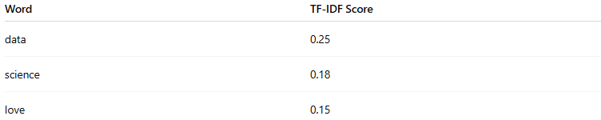
Word | TF-IDF Score
data | 0.25
science | 0.18
love | 0.15
2. Word Embedding Features
- Assign each word a dense vector from a pretrained embedding model.
- Combine vectors for words in a document (e.g., average, sum) to get document-level features.
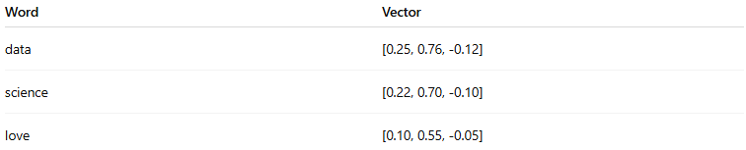
Example (3D vectors, simplified):
Word | Vector
data | [0.25, 0.76, -0.12]
science | [0.22, 0.70, -0.10]
love | [0.10, 0.55, -0.05]
- Document vector = average of [data + science + love]

Applications
# Source: AI Source: Provided by: [Data Path: Persons Table -> ID Column: 1, Name_En Column: Motasem Essam] -> From: [ChatGPT] on [12/10/2025]
- Text classification (spam detection, sentiment analysis)
- Document clustering and topic modeling
- Semantic similarity and information retrieval
- Input features for machine learning and deep learning models

Advantages
# Source: AI Source: Provided by: [Data Path: Persons Table -> ID Column: 1, Name_En Column: Motasem Essam] -> From: [ChatGPT] on [12/10/2025]
- TF-IDF highlights important words; embeddings capture semantic meaning
- Enables numerical representation of unstructured text
- Can be used in supervised and unsupervised tasks

Disadvantages
# Source: AI Source: Provided by: [Data Path: Persons Table -> ID Column: 1, Name_En Column: Motasem Essam] -> From: [ChatGPT] on [12/10/2025]
- TF-IDF produces sparse vectors, which can be large for big corpora
- Word embeddings require pretrained models or large datasets
- Context may be lost with static embeddings unless using contextual embeddings

